 Software Requirement Specifications
Eidiko System Integrators Version 1.0 December 5,2024

Software Understanding Document
Version 1.3
December 5, 2024

Client name : Fidelity Bank
Date : December 10, 2024
Last revised : March 28, 2025

Software Requirement Specification

Sign-off History

Version 1.0 Revision Date: January 5, 2024

Revision History
Title | Approver name | Signature | Sign off Date
Biller Onboarding Services | Theodore | ___T.A___
Request To Pay - Payments | Theodore | ___T.A___
Inward Services
Outward Services

Document version history: 1.0

Contents

Section 1: Overview

1.1 Purpose

1.2 Project Scope

1.3 Stakeholders

1.4 Timeline

Section 2: Existing Systems

2.1 System Hardware Inventory and Overview

2.2 System Inventory and Platform Overview

2.3 Database platform Overview

Section 3: Dependencies and Constraints

3.1 System Dependencies

3.2 Staffing Dependencies

3.3 Network Topology

3.4 Constraints

Section 4: Requirements

4.1 Business Requirements

4.2 Functional Requirements

4.3 Feasibility Requirements

Section 1: Overview

1.1 Purpose
This document provides a comprehensive specification for implementing an API-based system for RTP onboarding and biller management. It ensures a seamless interaction between Channels, Core Banking Systems (CBS), the RTP Database, and GhIPSS APIs. The provided flow diagrams are integrated to visually support each technical flow.

1.2 Project Scope
The Request to Pay (RTP) Integration Software project aims to develop an API-based platform to streamline the onboarding of billers, facilitate secure payment processing, and integrate seamlessly with the GhIPSS infrastructure. The scope includes the development of RESTful APIs to manage biller profiles, process payments, and enable real-time interactions between financial institutions, Core Banking Systems (CBS), and GhIPSS systems.

1.3 Stakeholders
The Request to Pay (RTP) Integration Software project has multiple stakeholders, both internal and external. The key stakeholders include Theodore Ametepay, Felix Adeh Essiene and Ranjeet Kumar who are directly involved with the project.

1.4 Timeline
The timeline of the project is 1 month.

Section 2: Existing Systems

2.1 System Hardware Inventory and Overview
The existing infrastructure of the bank includes hardware and systems required for running the App Connect Enterprise solution at Fidelity Bank. This platform is already in operation and serves as the middleware for integration with the GhIPSS system and Core Banking Systems (CBS).

2.2 System Inventory and Platform Overview
The middleware platform used for this project is IBM App Connect Enterprise. This platform provides the framework to develop and integrate 20 Request-to-Pay (RTP) services. The following tools and systems support the development:
- IBM App Connect for message flow and orchestration.
- Postman for API testing and validation.
- RFHUtil for messaging system interaction.
- Repository access for managing project artifacts.

2.3 Database platform Overview
The RTP database is central to the project and will house the following key datasets:
- Biller profiles, stored and updated via onboarding APIs.
- Callback logs, to track interactions with GhIPSS and channels.
- Payment request data, used to support individual and bulk payments.
The database must support high transaction volumes and provide seamless integration with the existing ESB architecture.

Section 3: Dependencies and Constraints

3.1 System Dependencies
- Integration with GhIPSS APIs for real-time payment processing.
- Access to Fidelity Bank's Core Banking Systems for synchronization of biller and payment data.
- Connectivity between App Connect Enterprise and GhIPSS via secure communication protocols.

3.2 Staffing Dependencies
- Availability of skilled IBM App Connect developers (minimum 3 for the development phase).
- A dedicated solution architect to ensure alignment with technical requirements.
- A project manager to oversee progress and facilitate communication.

3.3 Network Topology
The implementation relies on a secure network configuration that includes:
- VPN access for developers to interact with non-production and production systems.
- Segregated environments (Development, SIT, UAT, and Production) to maintain operational security and integrity.
- Firewall rules ensuring safe and controlled API communication with external systems.

3.4 Constraints
Not any as of now.

Section 4: Requirements

4.1 Business Requirements
The business requirements for the Request to Pay (RTP) Integration Software is building 20 services.

4.2 Functional Requirements
- This is high level architecture for the implementation

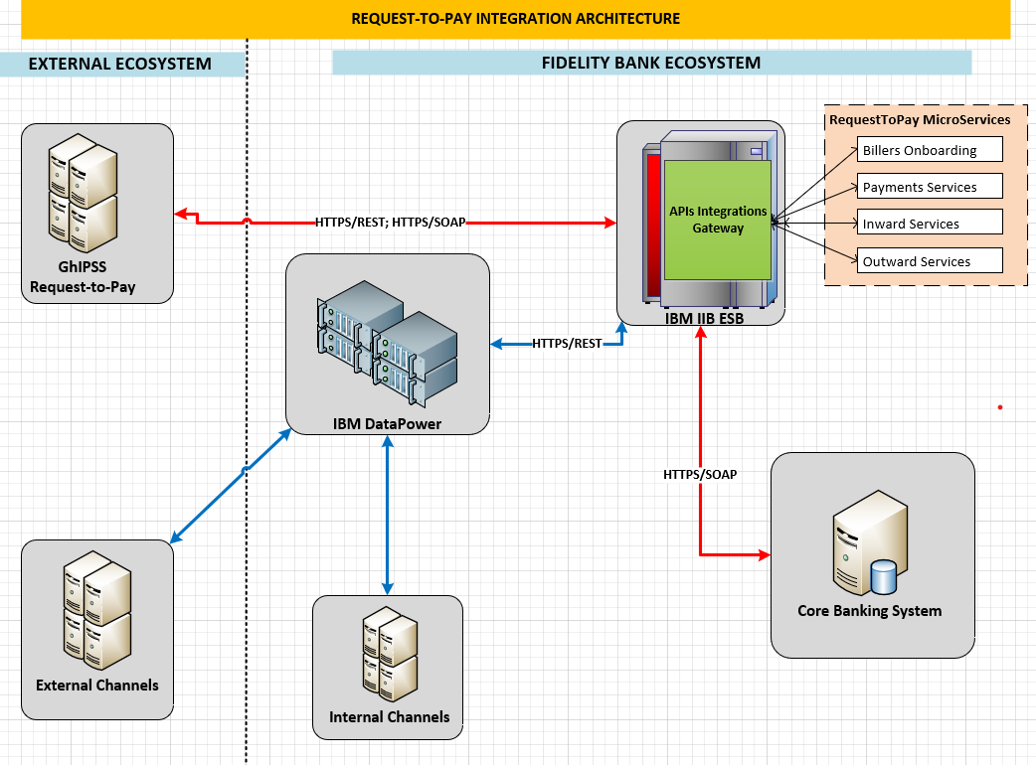

- This is the summary of Services for the developments from GhIPSS Document
 | REST Services to be Developed | Required APIs | GhIPSS Doc |  | Remark
A | Biller Onboarding Services:-
 | Operations
1 | Enrollment - Individual | 2 APIs  (GhIPSS & CBS) | 4.1 | 1 | Connected to Ghipss  19 - 12
2 | Enrollment - Bulk | 2 APIs  (GhIPSS & CBS) | 4.1 | 2
3 | Update | 1 API (GhIPSS) | 4.2 | 3
4 | Delete | 1 API (GhIPSS) | 4.3 | 4
5 | Query | 1 API (GhIPSS) | 4.4 | 5
6 | List | 1 API (GhIPSS) | 4.5 | 6
7. i | Callback URL to GhIPSS | 1 API |  | 7
ii | Callback URL to Channels | 1 API |  | 8 | 7
B | Request To Pay - Payments
 | Operations
1 | Biller Payment - Individual | 2 APIs | 5.1 | 1
2 | Biller Payment - Bulk | 2 APIs | 5.1 | 2
3 | Billers Notification | 2 APIs | 5.4 | 3 | Who is the biller here, and what is needed in specification from the biller?
4 | Payers Payment | 1 API | 5.2 | 4
5 | Payer’s Notification | 2 APIs | 5.5 | 5 | 12
C | Inward Services
 | Operations
1 | GIP & GhQR Inbound – NEC/NED | 1 API | 3 |  | done
2 | GIP & GhQR Inbound - FTC | 2 APIs | 2 |  | pending
3 | GIFMIS - FTD | 2 APIs | 1 |  | done
4 | GhanaPay Linkage | 1 API | 4 |  | Pending
5 | GhanaPay Update | 2 APIs | 5 |  | Pending
 |  |  |  |  | 17
D | Outward Services
 | Operations |  | 1
1 | GIP Outbound - NEC | 1 API | 1 |  | done
2 | GIP Outbound - FTC | 2 APIs | 1

- Proposed Development Delivery: 1 month

4.2.1 Biller Onboarding Services (Operations)

Enrollment - Individual
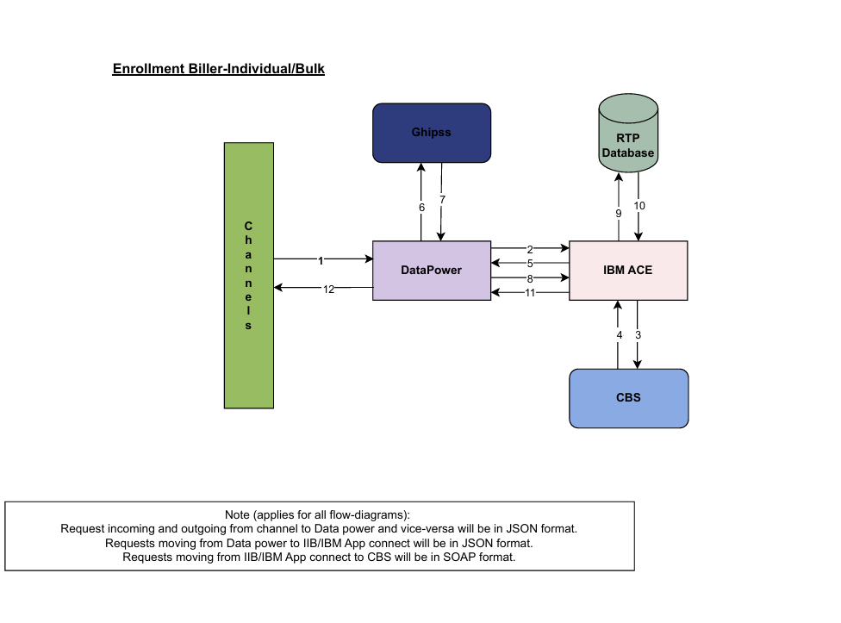
The stages in composite API Development on IIB:
1. Develop json API request for Apps/Channels to call
2. Mapping of core banking SOAP API to GhIPSS Enrollment API
3. Call GhIPSS Enrollment API request
4. Get response for GhIPSS Enrollment API
5. Returns response to Apps/Channels
6. Insert into RTP database details for enrollment upon successful response from GhIPSS
API URL:- https://10.180.XXX.XX:XXXX/RTPOnboarding

Enrollment - Bulk


This operation is used to do bulk enrolls or adds a new biller onto the RTP platform.

The service will be developed as composite API that allows Apps/Channels to call REST APIs to enroll customers.

The stages in composite API Development on IIB:
1. Develop json API request for Apps/Channels to call
2. Mapping of core banking SOAP API to GhIPSS Enrollment API
3. Call GhIPSS Enrollment API request
4. Get response for GhIPSS Enrollment API
5. Returns response to Apps/Channels
6. Insert into RTP database details for enrollment upon successful response from GhIPSS

Query
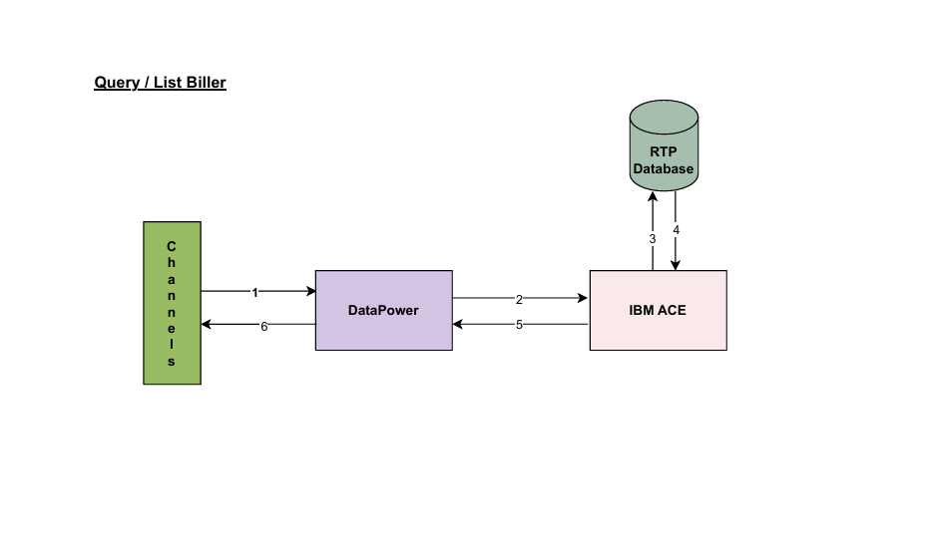

1. Develop json API request for Apps/Channels to call
2. Develop procedure on RTP database to fetch related data for the biller id
3. Use procedure, #2, to develop API on IIB using biller id
4. The API will return the below when biller id is received from the Channel
5. Returns response to Apps/Channels

Delete
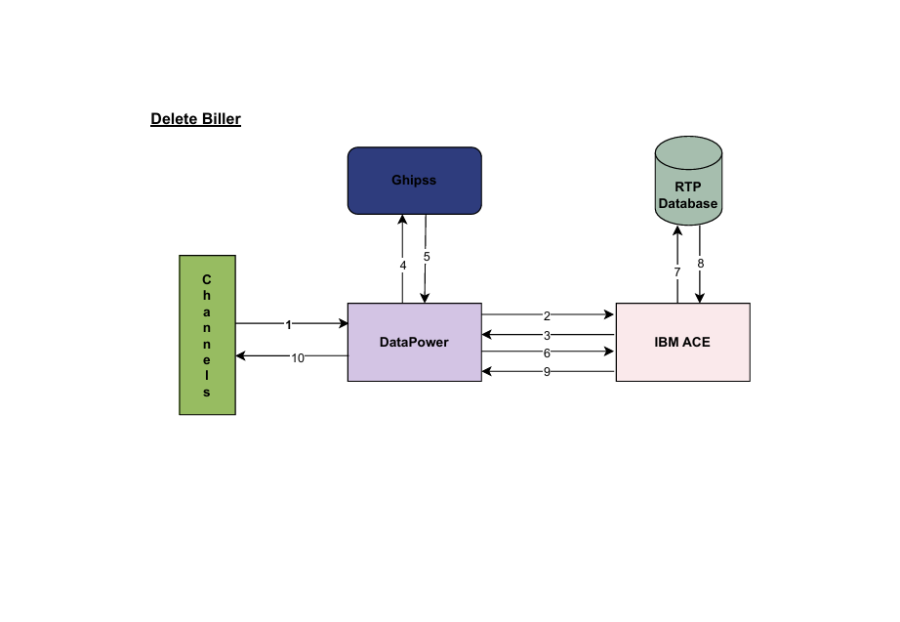

1. Develop json API request for Apps/Channels to call
2. IIB enrich the received data with below
3. IIB call GhIPSS Delete API to send
4. Get response from GhIPSS Delete API
5. Delete record from RTP database using billerId
6. Returns response to Apps/Channels

List


1. Develop json API request for Apps/Channels to call
2. Develop procedure on RTP database to fetch all onboarded customers
3. Use procedure, #2, to develop API on IIB using institutionId
4. The API will return the below when institutionId is received from the Channel
5. Returns response to Apps/Channels

Update

1. Channel makes Query call to fetch details
2. Channel makes Update call with the details fetch
3. IIB makes Update call to GhIPSS
4. IIB receives response from GhIPSS
5. IIB updates RTP database using billerId with updated data sent to GhIPSS
6. IIB receives response to Channel

G. Callback URLs to CHANNELS
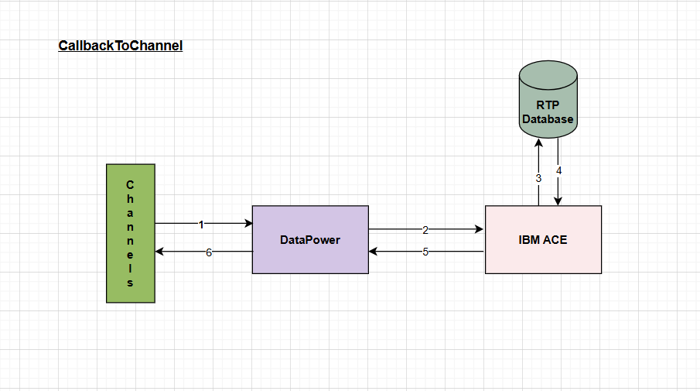
1. Channel makes Callback call to fetch details
2. Use procedure on RTP database to develop API on IIB using billerId
3. IIB fetch from RTP database using procedure with billerId
4. And the respective details are directly returned to Channels.

- Development of Composite APIs for:
  - Enrollment (Individual and Bulk)
  - Query
  - List
  - Update
  - Delete
  - Callback URL to CHANNELS
  - Callback URL to GHIPSS

- Data Flow and Integration:
  - Channels → DataPower → IIB/IBM App Connect → CBS.
  - GhIPSS API integrations for enrollment, updates, and deletions.
  - RTP Database synchronization for persistent records.

- Protocols:
  - JSON: For communication with channels.
  - SOAP: For CBS communication.
  - HTTPS: For secure transport.
  - Timestamp and signature validation for GhIPSS APIs.

4.2.2 Request To Pay - Payments

Biller Payment - Individual/Bulk
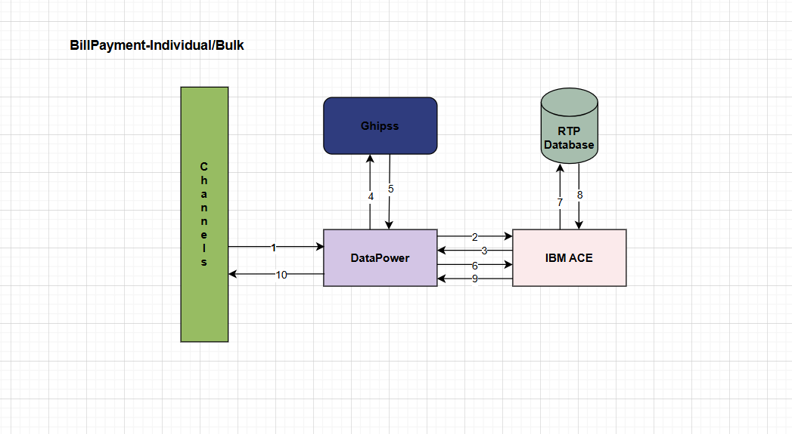

1. Develop json API request for Apps/Channels to call
2. Request from IIB to GhIPSS
3. Get response from GhIPSS API
4. Insert into RTP database details for request-to-pay upon successful response from GhIPSS
5. Returns response to Apps/Channels

Payers Payment
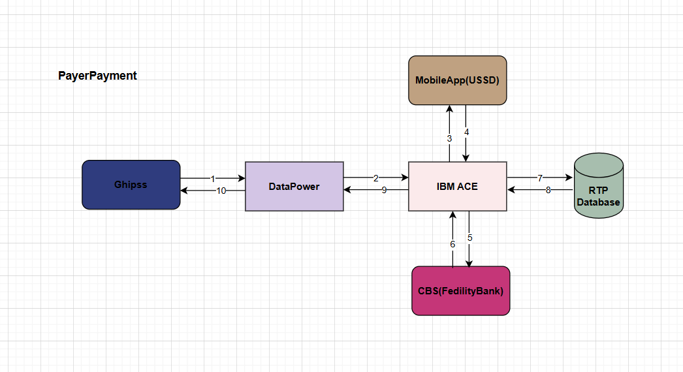

1. GhIPSS will initiate the request to IIB/ACE
2. IIB/ACE invoke a call from MobileApp/USSD to send payment request
3. MobileApp/USSD will give approval/decline response to IIB/ACE
4a. If response is decline, IIB/ACE will response decline to GHIPSS
4b. If response is approval, IIB/ACE will initiate CBS RT Service request to debit account for the payment in the CBS.
CBS will acknowledge the payment debit information to IIB/ACE.
4c. IIB/ACE will response to GHIPSS
4d. IIB/ACE will update this information in the RTP database.

Payers Notification

4.2.3 Inward Services

Name Enquiry Credit (NEC)

Name Enquiry Debit (NED)

Reversal

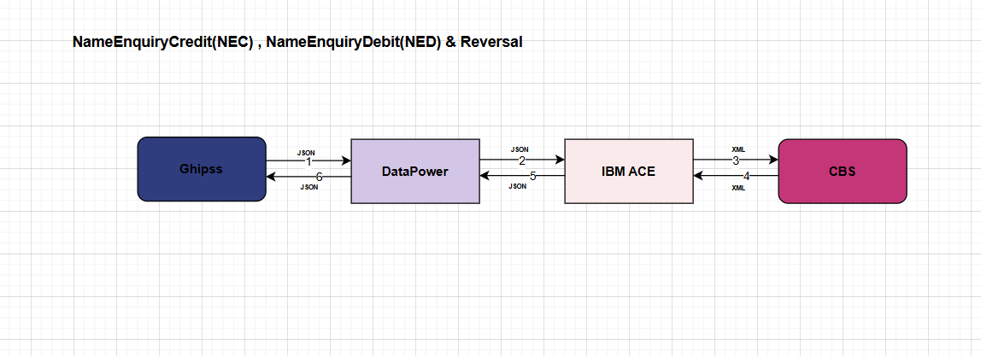
For Name Enquiry Credit, Name Enquiry Debit and Reversal the flow diagram is indicated as below:
- IIB Develop REST API with request for GhIPSS to call
- IIB insert into RTP Database
- Mapping of GhIPSS Payload to core banking SOAP API
- IIB calls CBA API to fetch customer details
- Mapping of GhIPSS Payload to core banking SOAP API
- IIB response to GhIPSS

Funds Transfer Debit (FTD)

Funds Transfer Credit (FTC)

QR Code Funds Transfer Credit (QRC)

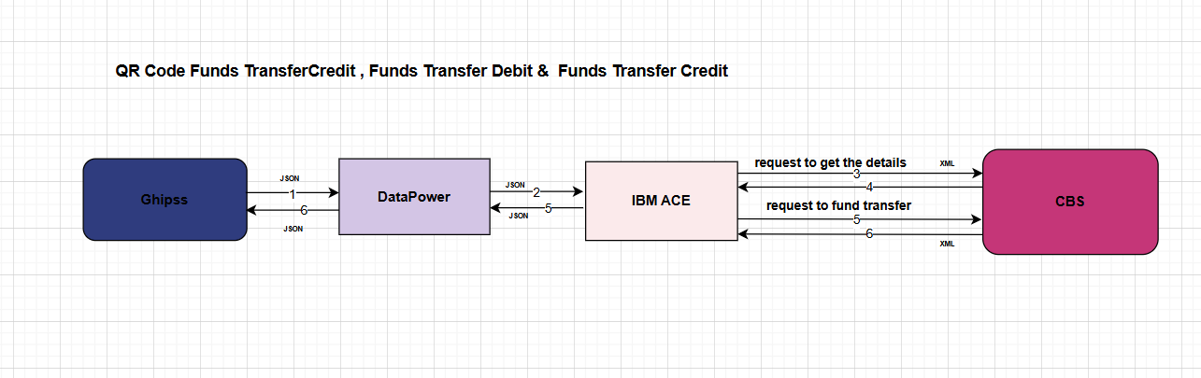
For Funds Transfer Debit, Funds Transfer Credit and QR Code Funds Transfer Credit the flow diagrams are similar:
- IIB Develop REST API with request for GhIPSS to call
- IIB insert into RTP Database
- IIB calls CBS CustInfoService to fetch branch code using receiverAccount
- Mapping of GhIPSS Payload to core banking SOAP API
- IIB use branch code, and details in GhIPSS Request to invoke CBS RT Call
- Mapping of core banking response to response to GhIPSS
- IIB response to GhIPSS

GhanaPay Linkage

GhanaPay Update

4.2.4 Outward Services

Name Enquiry Credit (NEC)

Single

Bulk

Funds Transfer Credit (FTC) Single

Internal ---- The request has account number in accountToDebit tag

Partners ---- The request has 4 letter code in accountToDebit tag mapped to account number backend

Funds Transfer Credit (FTC) Bulk

Internal ---- The request has account number in accountToDebit tag

Partners --- The request has 4 letter code in accountToDebit tag mapped to account number backend

